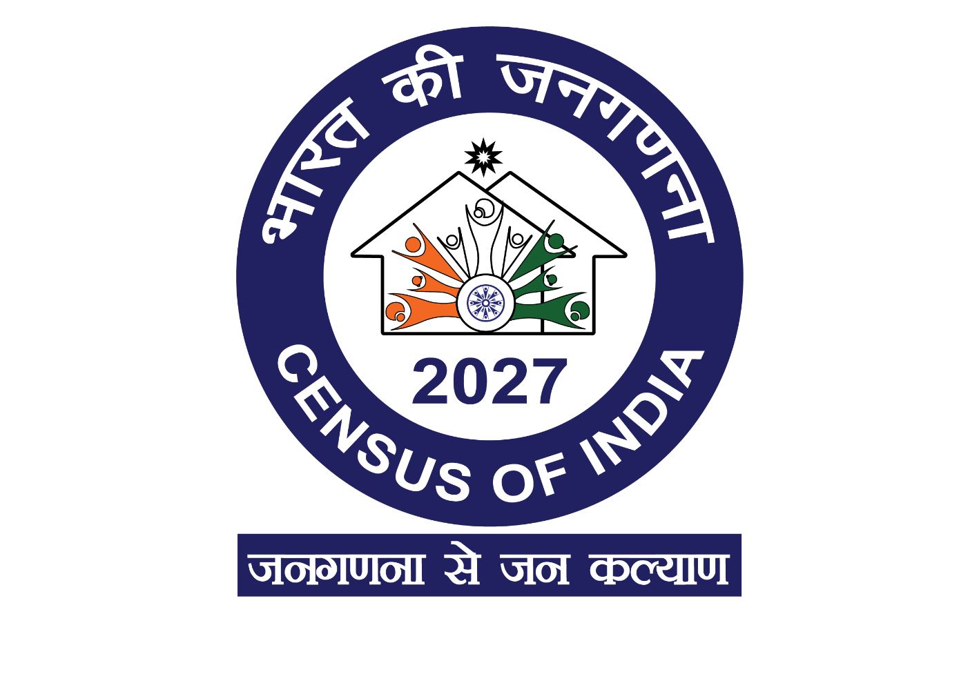

Address-
Directorate of Census Operations, Tripura
Ramnagar Lane 1, Bye Lane-2(Left Side)
Agartala, Tripura-799001
Email – dco-tri.rgi@nic.in

